**SQL LIBRARY TASK 3 10%**

**NAME:** Nurfirdaus Liyana Binti Farithal

**CLASS:** 1K6

**TITLE:** SQL Exercise: Library Database

1. Creating Library Database and Table with Data

**CODES**

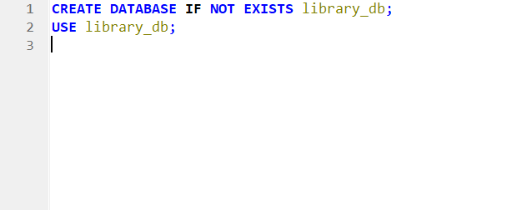

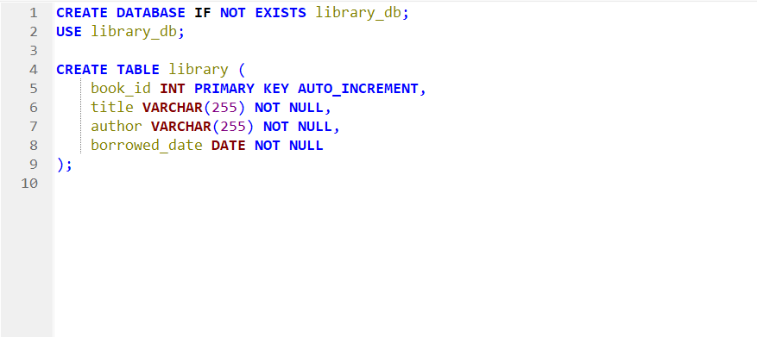

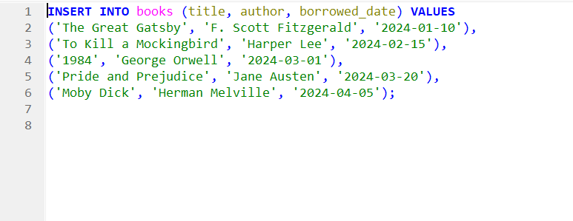

**RESULTS**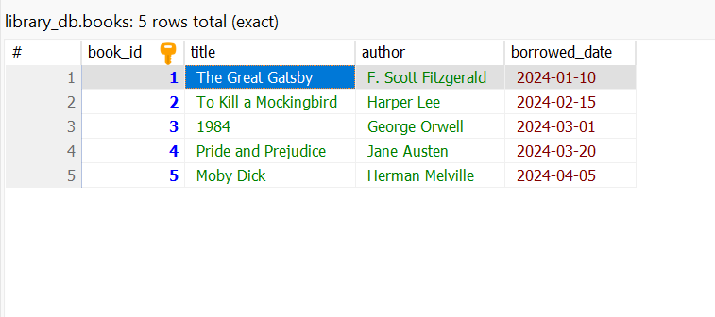

1. Queries (Listing All Books)

**CODES**

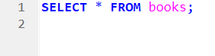

**RESULTS**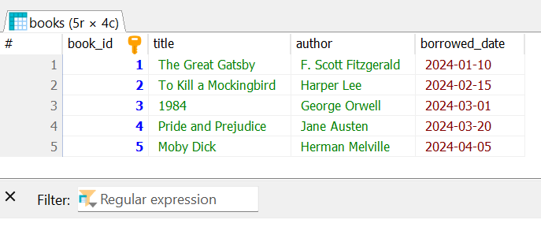

1. Queries (Find Books By a Specific Author)

**CODES**

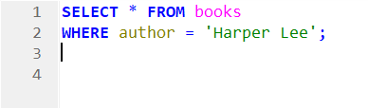

**RESULTS**

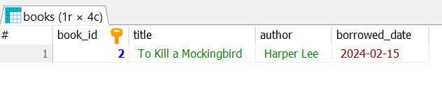

1. Queries (Find Books By a Specific Date)

**CODES**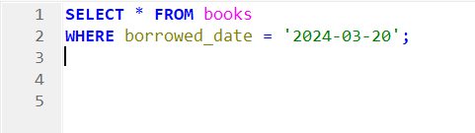

**RESULTS**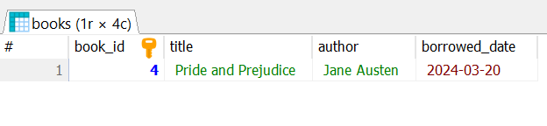

1. Queries (Find Books After a Certain Date)

**CODES**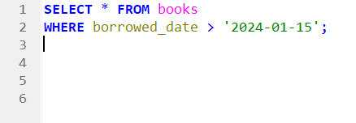

**RESULTS**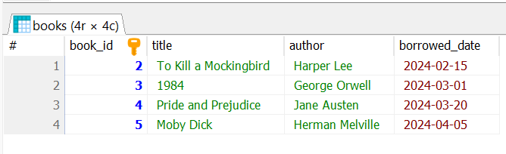

1. Update Borrowed Date

**CODES**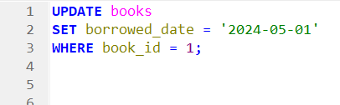

**RESULTS**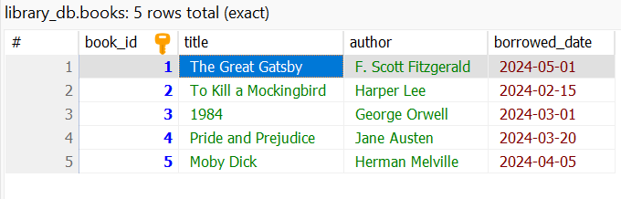

1. Delete a Book

**CODES** 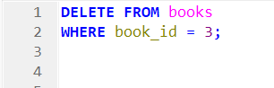

**RESULTS**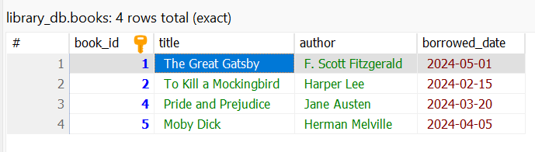

1. Re-add a Book

**CODES**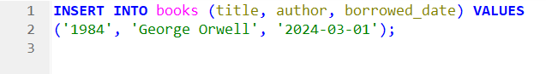

**RESULTS**

